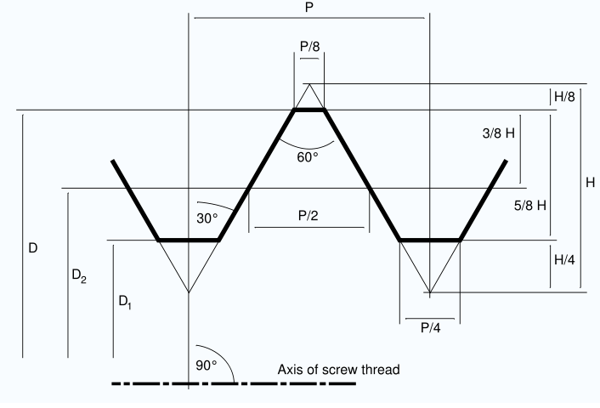
This is a standard thread profile. ^^^^^^^^^^^^

Below are the measurements that I need to correctly make the threads for the mandrels.
D = Major dia. of thread __________
D1 = Minor dia. of thread _________
P = Pitch of thread distance of corresponding point one thread away__________
H*0.625 or thread depth___________
Angle of thread 30 deg. Or 60 deg. Included is standard. Custom__________________
P/8 standard or crest width of Custom____________
P/4 standard or root width Custom_____________

AAAAAAAAA|
BBB|
CCCCC|DDD
BBB|
AAAAAAAAA|

Sanding Diameter: A:______________
Pin shoulder dia. if applicable:
B:____________ Shoulder Length B1:____________
Thread Length: C:______________
Pilot dia. if Applicable: D:________________ Pilot Length D1:_____________
Total Length of thread from face of joint to end of pin: _________________

